**Australian Islamic College 2019**

**ATAR Chemistry Units 3 and 4**

**Task 5 (Weighting: 3%)**

**Volumetric Analysis Test**

Test Time: 40 minutes

Please do not turn this page until instructed to do so.

|  |  |
| --- | --- |
| **First Name** | **Surname** |
| **ANSWERS** |  |

|  |
| --- |
| **Teacher** |
|  |

|  |  |
| --- | --- |
| **Mark / 32** | **Percentage** |
|  |  |

Equipment allowed: Pens, pencils, erasers, whiteout, rulers and non-programmable calculators permitted by the Schools Curriculum and Standards Authority.

**Special conditions**:

2 marks will be deducted for failing to write your full name on this test paper.

**Teacher help**: Your teacher can only help you during your test in one situation.

If you believe there is a mistake in a question show your teacher and your teacher will tell you whether or not there is a mistake in the question and if appropriate, how to fix that mistake.

**Spelling of Science words** should be correct. Science words with more than one letter wrong (wrong letter and/or wrong place) will be marked wrong.

**Equations** must be written balanced and with correct state symbols or they will be marked wrong.

Questions must be answered in this booklet.

Total marks: 32

1. Here is a description of a titration.

A titration was conducted to determine the concentration of a solution of hydrochloric acid. 25.00 mL aliquots of hydrochloric acid were titrated against a standard solution of 0.150 mol L-1 sodium hydroxide.

The apparatus used in the titration is shown below.

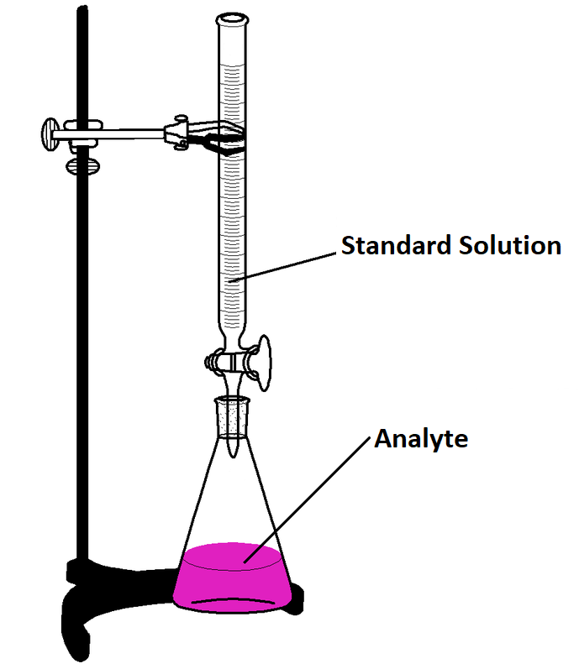

* 1. Referring to the diagram above, identify the following substances. Circle the correct answer from the choices given. [4 marks, 1 mark each]
     1. The substance placed in the burette for the titration.

HCl **NaOH** distilled water

* + 1. The substance placed in the conical flask for the titration.

**HCl** NaOH distilled water

* + 1. The liquid used for the final rinse of the burette.

HCl **NaOH** distilled water

* + 1. The liquid used for the final rinse of the conical flask.

HCl NaOH **distilled water**

* 1. Is the sodium hydroxide solution likely to be a primary standard solution or a secondary standard solution? Justify your answer. [2 marks]

**Secondary (1).**

**Sodium hydroxide is not used as a primary standard OR any one correct reason why sodium hydroxide is not used as a primary standard (1).**

* 1. The results of the titrations are given in the table below.

|  |  |  |  |  |  |
| --- | --- | --- | --- | --- | --- |
|  | Rough Estimate | Trial 1 | Trial 2 | Trial 3 | Trial 4 |
| Initial burette reading (mL) | 0.00 | 3.60 | 10.20 | 5.50 | 4.40 |
| Final burette reading (mL) | 37.20 | 38.60 | 45.30 | 40.60 | 28.60 |
| Titre (mL) | **37.20** | **35.00** | **35.10** | **35.10** | **24.20** |

What average value for the titre should be used for the calculations of the hydrochloric acid concentration? [1 mark]

**35.07 mL (1 mark; ½ off for wrong / no units)**

* 1. Examination of the data in the results table above suggests a mistake was made during the titration and/or during the recording of results. Is this likely to be a random error or a systematic error. Justify your response.

[2 marks]

**Random (1).**

**Only one trial was affected by the error (1).**

* 1. Determine the concentration of hydrochloric acid. [2 marks]

**HCl(aq) + NaOH(aq) 🡪 NaCl(aq) + H2O(l)**

**n(NaOH) = cV = 0.150 x 0.03507 = 0.00526 mol (1)**

**SR = 1/1 = 1**

**n(HCl) = 1 x 0.00526 = 0.00526 mol (or 1)**

**c(HCl) = n/V = 0.00526 / 0.025 = 0.21 mol L-1**

**(1, ½ off for wrong/no units)**

* 1. Explain how the calculated concentration of hydrochloric acid would be affected if the final rinse of the volumetric pipette was performed using distilled water. Circle the correct answer below.

[1 mark]

Final calculated concentration of HCl will be

Too high **Too low** Unaffected

* 1. Explain how and why the calculated concentration of hydrochloric acid would be affected if, every time the volume of liquid in the burette was measured, the burette was viewed from below the meniscus, rather than level with the meniscus.

[2 marks]

**Unaffected / no change (1).**

**Because the initial and final reading of the burette would be affected in the same way (1).**

1. List four reasons why sodium hydrogen carbonate is a good choice of a solute to make a primary standard solution.

[2 marks; ½ each]

**Any 4 of these reasons; ½ each.**

* + **A (relatively) large molar mass.**
  + **Low cost.**
  + **High purity.**
  + **Stable in the presence of air.**
  + **Has no water of hydration / is anhydrous.**
  + **Dissolves readily in solvent / water.**

1. An experiment was set up to calculate the amount of citric acid present in lemon juice. Citric acid has a formula of C6H8O7 and is a weak triprotic acid. 8.00 g of the lemon juice was mixed with 50.00 mL of 0.500 mol L-1 NaOH(aq) and stirred thoroughly. The resulting solution was filtered and immediately titrated against 1.05 mol L-1 HCl(aq).

The average titre of HCl was 15.90 mL.

Calculate the % (by mass) of citric acid in the lemon juice.

[6 marks]

**HCl(aq) + NaOH(aq) 🡪 NaCl(aq) + H2O(l)**

**n(HCl) = cV = 1.05 x 0.01590 = 0.016695 mol**

**SR = 1, n(NaOH) = 0.016695 mol**

**i.e. n(NaOH after reaction with citric acid) = 0.016695 mol (1)**

**n(NaOH before reaction with citric acid) = cV**

**= 0.500 x 0.05000 = 0.02500 mol (1)**

**n(NaOH used in reaction with citric acid)**

**= 0.02500 – 0.016695 = 0.008305 mol (1)**

**C6H8O7(aq) + 3NaOH(aq) 🡪3H2O(l) + Na3C6H5O7(aq)**

**SR C6H8O7 / NaOH = 1/3**

**n(C6H8O7) = 1/3 x 0.008305 = 0.002768333 mol (1)**

**m(C6H8O7) = nM**

**= 0.002768333 x ((6 x 12.01) + (8 x 1.008) + (7 x 16.00))**

**= 0.53186 g (1)**

**% composition = (0.53186 / 8.00) x 100 = 6.65 % (1)**

1. Phosphoric acid is a weak, triprotic acid. In a volumetric analysis experiment, a solution of approximately 0.2 mol L-1 phosphoric acid (H3PO4) is titrated with a standard solution of 0.200 mol L-1 sodium hydroxide in order to calculate the accurate concentration of the acid. 30.00 mL of the sodium hydroxide solution was pipetted into a conical flask, and the phosphoric acid added from the burette.
   1. Write an ionic equation, including state symbols, for the reaction occurring.

[1 mark; no half marks]

3**OH-(aq) + H3PO4(aq) 🡪 3H2O(l) + PO43-(aq)**

* 1. On the axis below, sketch a graph showing how the pH would be expected to change during the titration, until an excess of the acid was added.

[3 marks]

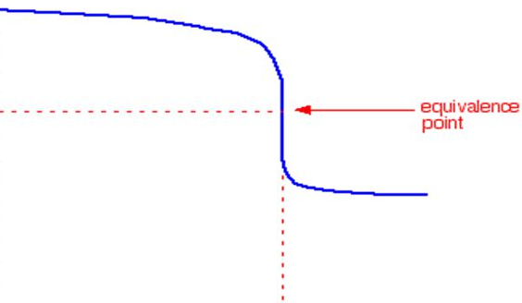

14

**pH**

7

1

**Volume of H3PO4 Added (mL)**

**pH starts near 14 (1)**

**pH ends near 4 or 5 or 6 ish (1)**

**Shape correct (1).**

* 1. On the graph above, label the equivalence point for this reaction.

[1 mark]

**Equivalence point should be where the curve is vertical and pH around pH 8 or 9 or 10 ish (1).**

|  |  |  |  |
| --- | --- | --- | --- |
| **Indicator** | **Approximate pH Range for Colour Change** | **Colour at Low pH** | **Colour at High pH** |
| **Methyl Orange** | **3.2 – 4.4** | **Red** | **Yellow** |
| **Bromothymol Blue** | **6.0 – 7.6** | **Yellow** | **Blue** |
| **Phenolphthalein** | **8.2 – 10.0** | **Colourless** | **Pink** |
| **Litmus** | **5.5 – 8.2** | **Red** | **Blue** |
| **Bromocresol Green** | **3.8 – 5.4** | **Yellow** | **Blue** |

* 1. Referring to the table above, give the name of an indicator that would be suitable for use in this titration.

[1 mark]

**Phenolphthalein (1).**

* 1. Describe the colour change that would occur that would indicate the endpoint of the titration.

[1 mark]

**Pink to colourless (1). No follow-on mark.**

1. When preparing for a different titration 1.54 g of primary standard was dissolved in 250 mL of distilled water instead of 1.45 g, as intended. What type of error will this cause? Circle the correct answer from the three choices below. [1 mark]

**Systematic** / Random / No error

1. The titration curve below was produced by a group of students conducting an acid-base titration. 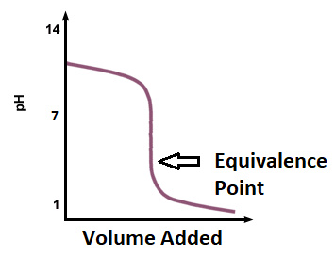
   1. Suggest any combination of acid and base that the students were using.

[1 mark for both answers correct, no half marks]

Example of acid being used: **Any strong acid e.g. HCl**

Example of base being used: **Any weak soluble base e.g. NH3**

* 1. What was in the burette during the students’ experiment, the acid or the base?

[1 mark]

**Acid / name of strong acid answered above (1).**

**END OF TEST**